**SPRINT 3**

|  |  |
| --- | --- |
| **Date** | **10 November 2022** |
| **TEAM ID** | **PNT2022TMID50334** |
| **Project name** | **IOT based smart crop production** |
| **Mark** | **20 marks** |

MIT App inventor to design App

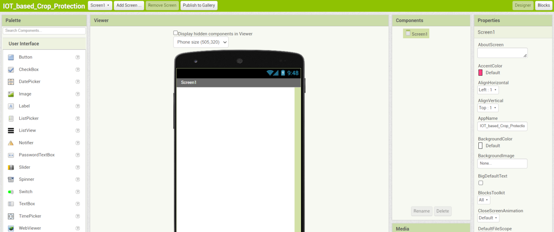

Design and testing the app to get values

